JAVA SHORT-TERM COURSE
PROJECT REPORT
LOG ANALYZER AND MONITORING TOOL
Advanced Java Programming
Project Submitted By
Chakaravarthi.R.P
Diwan Maideen.S
Divakar.K
Akash.M

Java • HTTP Server • Log Analysis • Web Interface

1. Project Overview
The Log Analyzer and Monitoring Tool is a small Java-based web application designed to make log inspection easier. It runs a lightweight HTTP server and provides a browser interface where a user can paste log text or select a .log or .txt file for analysis.
- Accept log text through a web form.
- Allow .log and .txt files to be loaded into the analysis area.
- Count INFO, WARN and ERROR entries.
- Identify FAILED, EXCEPTION and TIMEOUT messages as alerts.
- Display the analysis as a simple monitoring report in the browser.

2. Problem Statement
Application and system log files can become difficult to inspect manually as their size and number of messages increase. Important warnings and errors may be missed when a user has to read every line. The proposed Log Analyzer and Monitoring Tool provides a simple centralized view of log severity counts and alert-related messages, reducing the effort required to identify important events.

3. Objectives
1. Provide a simple browser-based interface for log analysis.
2. Accept both pasted log text and supported log/text files.
3. Count INFO, WARN and ERROR entries automatically.
4. Detect FAILED, EXCEPTION and TIMEOUT conditions as alerts.
5. Present the analysis in a clear summary format.
6. Demonstrate practical use of Java networking and string processing.

4. Technology Used
Technology | Purpose
Java 11 or newer | Programming language and application implementation
Java HTTP Server | Runs the local web application
HTML/CSS | Browser interface and report presentation
Java String Processing | Log classification and counting
VS Code | Project development and execution
Git/GitHub | Project version control and submission

5. System Architecture
The application follows a lightweight request-processing flow. The Java HTTP server receives browser requests, the analyzer processes the supplied log text, and the result is returned as an HTML monitoring report.
User / Chrome Browser
↓
Java HTTP Server (Port 8080)
↓
Log Input → Log Analyzer → Classification & Counting
↓
Monitoring Report (INFO / WARNINGS / ERRORS / ALERTS)
The current implementation creates the root endpoint at / and the analysis endpoint at /analyze. The server starts on port 8080.

6. Main System Flow
1. Start the Java application.
2. Open the local monitoring page in Chrome.
3. Paste log text or choose a .log/.txt file.
4. Submit the log for analysis.
5. Convert the input to a consistent case for classification.
6. Count INFO, WARN and ERROR entries.
7. Count FAILED, EXCEPTION and TIMEOUT occurrences as alerts.
8. Display the resulting monitoring report.

7. Main Modules
Module | Responsibility | Current Implementation
Web Server | Starts the application and handles HTTP requests | HttpServer on port 8080
Input Module | Accepts pasted text or local text/log files | HTML form + file reader
Log Analyzer | Processes each log line | report() method
Severity Counter | Counts INFO, WARN and ERROR | Keyword matching
Alert Detector | Counts alert-related events | FAILED / EXCEPTION / TIMEOUT
Report Module | Builds summary cards | HTML generated by Java

8. Log Analysis Rules
The current analyzer converts each line to uppercase before checking keywords. A line containing INFO increments the INFO count; WARN increments the warning count; ERROR increments the error count. A line containing FAILED, EXCEPTION or TIMEOUT increments the alert count.
Detected Pattern | Category
INFO | Information
WARN | Warning
ERROR | Error
FAILED | Alert
EXCEPTION | Alert
TIMEOUT | Alert

9. Sample Test Data
The supplied sample log contains four entries: INFO for application startup, WARN for a database connection timeout, ERROR for a failed login, and DEBUG for a retry operation.
2026-09-17 09:00:00 INFO Application started
2026-09-17 09:01:12 WARN Connection timeout while contacting database
2026-09-17 09:02:03 ERROR Login failed for user admin
2026-09-17 09:03:10 DEBUG Retrying database connection

10. Expected Analysis for the Sample
Metric | Count
INFO | 1
WARNINGS | 1
ERRORS | 1
ALERTS | 2
The alert count is 2 because the sample contains TIMEOUT and FAILED. DEBUG is not included in the displayed severity counters.

11. Project Structure
Log Analyzer Project
├── hello.java
├── README.md
├── sample.log
├── .gitignore
└── hello.class

12. Important Java Implementation
The main Java class creates the HTTP server, maps the browser routes and performs the log analysis. The analysis logic iterates through log lines and checks for the defined keywords.
HttpServer server = HttpServer.create(new InetSocketAddress(8080), 0);
server.createContext("/", hello::showPage);
server.createContext("/analyze", hello::analyze);
server.start();

13. How to Run
1. Open the project in VS Code.
2. Ensure Java 11 or newer is installed.
3. Open the integrated terminal.
4. Compile using: javac hello.java
5. Run using: java hello
6. Open http://localhost:8080 in Chrome.
7. Paste log text or choose a .log/.txt file and select Analyze Log.

14. GitHub Submission
The project README includes Git commands for initializing the repository, adding the project files, committing the project, setting the main branch, connecting the GitHub remote and pushing the project. The actual repository URL can be added after the team creates or confirms its GitHub repository.

15. Testing
Test Case | Input / Action | Expected Result
1 | Start Java program | Server runs on localhost:8080
2 | Open root page | Java Log Monitor page appears
3 | Paste sample log | Log text appears in analysis area
4 | Analyze sample log | INFO, WARNINGS, ERRORS and ALERTS counts are displayed
5 | Load .log/.txt file | File content is placed in the text area

16. Advantages
- Simple and easy-to-use browser interface.
- Works locally without requiring a separate application server.
- Reduces manual effort in identifying common log severity keywords.
- Provides an immediate summary of important log categories.
- Easy to extend with additional log rules and monitoring features.

17. Future Enhancements
- Add date/time filtering and search.
- Support more log levels such as DEBUG and TRACE in the displayed report.
- Add charts and graphical dashboards.
- Support larger log files with more efficient processing.
- Add configurable alert rules.
- Store analysis history for later comparison.
- Add authentication and role-based access for multi-user deployments.

18. Conclusion
The Log Analyzer and Monitoring Tool demonstrates how Java can be used to build a practical browser-based utility. The project combines a lightweight Java HTTP server, HTML interface and keyword-based log analysis to provide a quick summary of INFO, WARN, ERROR and alert-related events. It provides a foundation that can be extended into a more advanced monitoring solution.

11. Application Screenshot
Screenshot 1 – Java Log Monitor with Sample Log Analysis
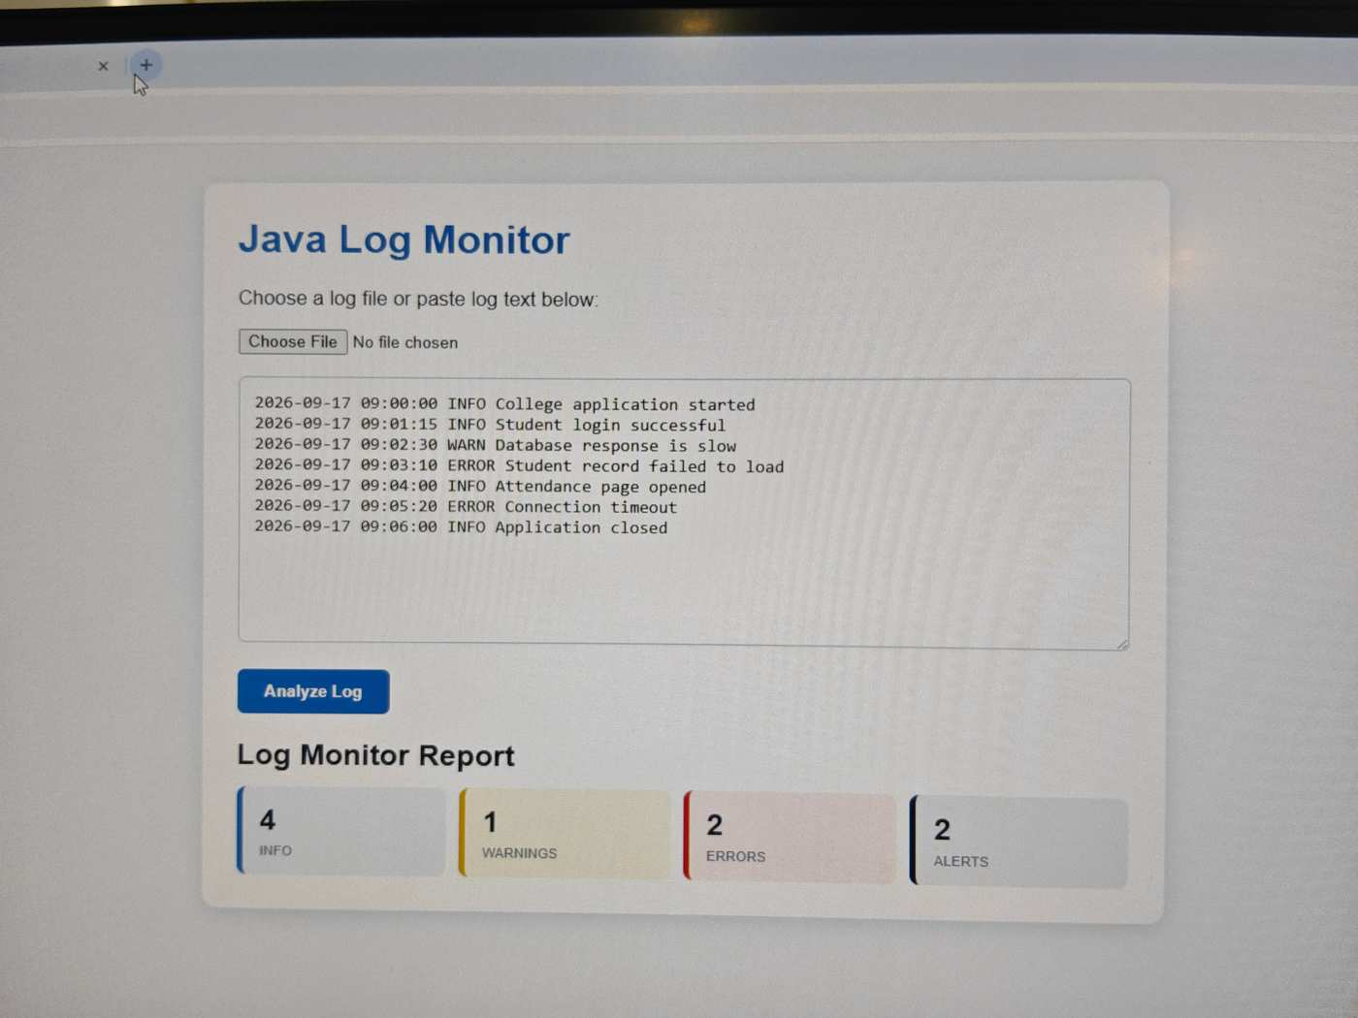
The screenshot shows the Java Log Monitor running in the browser, with sample log entries loaded and the resulting INFO, WARNINGS, ERRORS and ALERTS summary displayed.
Observed result: 4 INFO entries, 1 WARNING, 2 ERRORS and 2 ALERTS are displayed for the shown sample.

